Code Smells Identified
Package java/org/jabref/preferences/

1. java/org/jabref/preferences/GuiPreferences.java: line 28-35

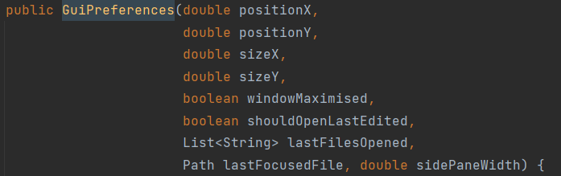

Problem: The constructor of this class has too many parameters (9 parameters, which is greater than the 7 authorized).

Refactoring Proposal: Create a new class which deals with the positionX, positionY, sizeX and sizeY and this code smell should be solved.

2. java/org/jabref/preferences/JabRefPreferences.java: line 146 and 413

Problem: Names should not differ only by capitalization.

Refractoring Proposal: change private Language language to private Language currLanguage.
3. java/org/jabref/preferences/JabRefPreferences.java: lines 747-789
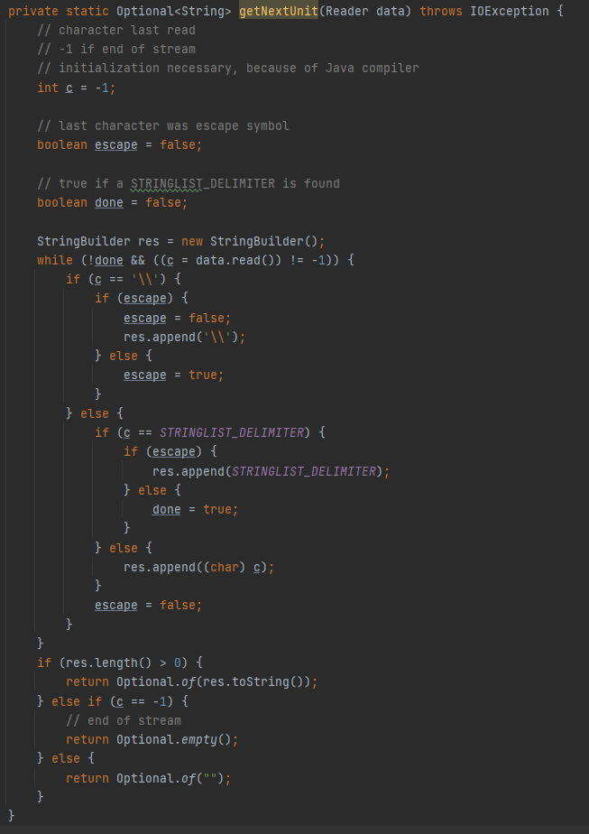
Problem: Method is too complex thus hard to maintain.

Refractoring Proposal: More comments should be added to better explain this method or it should be broken into smaller methods.

